Lab - Troubleshoot EIGRP for IPv6

# Topology

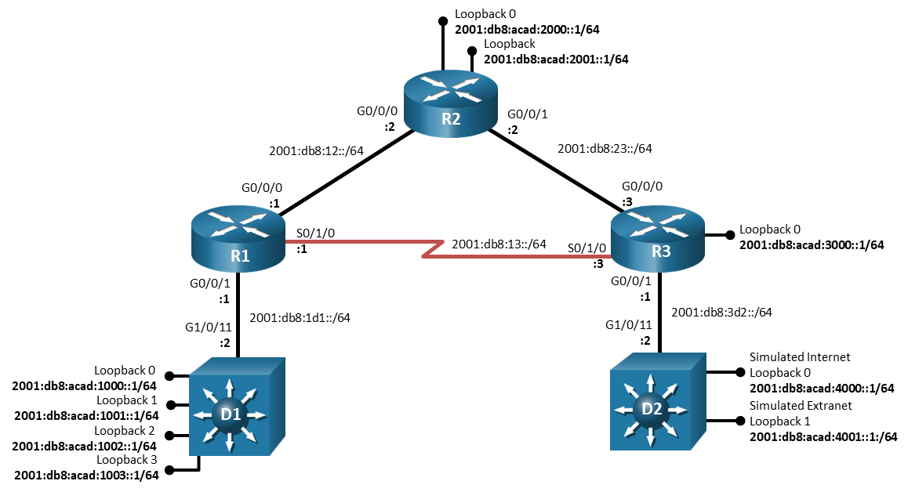

# Addressing Table

| Device | Interface | IPv6 Address/Prefix Length | Link-Local Address |
| --- | --- | --- | --- |
| R1 | G0/0/0 | 2001:db8:12::1/64 | fe80::1:1 |
| R1 | G0/0/1 | 2001:db8:1d1::1/64 | fe80::1:2 |
| R1 | S0/1/0 | 2001:db8:13::1/64 | fe80::1:3 |
| R2 | G0/0/0 | 2001:db8:12::2/64 | fe80::2:1 |
| R2 | G0/0/1 | 2001:db8:23::2/64 | fe80::2:2 |
| R2 | Loopback 0 | 2001:db8:acad:2000::1/64 | fe80::2:3 |
| R2 | Loopback 1 | 2001:db8:acad:2001::1/64 | fe80::2:4 |
| R3 | G0/0/0 | 2001:db8:23::3/64 | fe80::3:1 |
| R3 | G0/0/1 | 2001:db8:3d2::1/64 | fe80::3:2 |
| R3 | S0/1/0 | 2001:db8:13::3/64 | fe80::3:3 |
| R3 | Loopback 0 | 2001:db8:acad:3000::1/64 | fe80::3:4 |
| D1 | G1/0/11 | 2001:db8:1d1::2/64 | fe80::d1:1 |
| D1 | Loopback 0 | 2001:db8:acad:1000::1/64 | fe80::d1:2 |
| D1 | Loopback 1 | 2001:db8:acad:1001::1/64 | fe80::d1:3 |
| D1 | Loopback 2 | 2001:db8:acad:1002::1/64 | fe80::d1:4 |
| D1 | Loopback 3 | 2001:db8:acad:1003::1/64 | fe80::d1:5 |
| D2 | G1/0/11 | 2001:db8:3d2::2/64 | fe80::d2:1 |
| D2 | Loopback 0 | 2001:db8:acad:4000::1/64 | fe80::d2:2 |
| D2 | Loopback 1 | 2001:db8:acad:4001::1/64 | fe80::d2:3 |

# Objectives

Troubleshoot network issues related to the configuration and operation of EIGRP for IPv6.

# Background / Scenario

In this topology, R1, R2, R3, D1, and D2 are EIGRP neighbors. Switch D1 provides connectivity for a large branch of the network, R2 provides connectivity for a small branch, R3 supports a single LAN enclave, and switch D2 provides both an internet connection and an extranet connection. You will be loading configurations with intentional errors onto the network. Your tasks are to FIND the error(s), document your findings and the command(s) or method(s) used to fix them, FIX the issue(s) presented here and then test the network to ensure both of the following conditions are met:

* + - * 1. the complaint received in the ticket is resolved
        2. full reachability is restored

**Note**: The routers used with CCNP hands-on labs are Cisco 4221 with Cisco IOS XE Release 16.9.4 (universalk9 image). The switches used in the labs are Cisco Catalyst 3650 with Cisco IOS XE Release 16.9.4 (universalk9 image). Other routers, switches, and Cisco IOS versions can be used. Depending on the model and Cisco IOS version, the commands available and the output produced might vary from what is shown in the labs. Refer to the Router Interface Summary Table at the end of the lab for the correct interface identifiers.

**Note**: Make sure that the switches have been erased and have no startup configurations. If you are unsure, contact your instructor.

# Required Resources

* 3 Routers (Cisco 4221 with Cisco IOS XE Release 16.9.4 universal image or comparable)
* 2 Switches (Cisco 3560 with Cisco IOS XE Release 16.9.4 universal image or comparable)
* 1 PC (Choice of operating system with terminal emulation program installed)
* Console cables to configure the Cisco IOS devices via the console ports
* Ethernet and serial cables as shown in the topology

# Instructions

## Trouble Ticket 5.1.3.1

Scenario:

You took a spring break vacation, leaving the junior network administrator with some seemingly simple tasks. The routing table was to be reduced in size while the extranet on D2 and the enclave on R3 would not be visible in the routing table at all. Routing to the internet via D2 should work. Future additions to the large branch at R1 should be accounted for in the routing table so that when those networks are added (the network addresses are 2001:db8:acad:1004::/64, 2001:db8:acad:1005::/64, 2001:db8:acad:1006::/64, and 2001:db8:acad:1007::/64), there is no change to the routing table. The junior network administrator was not very successful. Now it is up to you to find and fix the misconfigurations before the CIO returns.

Use the commands listed below to load the configuration files for this trouble ticket:

|  |  |
| --- | --- |
| Device | Command |
| R1 | **copy flash:/enarsi/5.1.3.1-r1-config.txt run** |
| R2 | **copy flash:/enarsi/5.1.3.1-r2-config.txt run** |
| R3 | **copy flash:/enarsi/5.1.3.1-r3-config.txt run** |
| D1 | **copy flash:/enarsi/5.1.3.1-d1-config.txt run** |
| D2 | **copy flash:/enarsi/5.1.3.1-d2-config.txt run** |

* Passwords on all devices are **cisco12345**. If a username is required, use **admin**.
* When you have fixed the ticket, change the MOTD on EACH DEVICE using the following command:

**banner motd # This is $(hostname) FIXED from ticket <ticket number> #**

* Then save the configuration by issuing the **wri** command (on each device).
* Inform your instructor that you are ready for the next ticket.
* After the instructor approves your solution for this ticket, issue the **reset.now** privileged EXEC command. This script will clear your configurations and reload the devices.

# Router Interface Summary Table

| Router Model | Ethernet Interface #1 | Ethernet Interface #2 | Serial Interface #1 | Serial Interface #2 |
| --- | --- | --- | --- | --- |
| 1800 | Fast Ethernet 0/0 (F0/0) | Fast Ethernet 0/1 (F0/1) | Serial 0/0/0 (S0/0/0) | Serial 0/0/1 (S0/0/1) |
| 1900 | Gigabit Ethernet 0/0 (G0/0) | Gigabit Ethernet 0/1 (G0/1) | Serial 0/0/0 (S0/0/0) | Serial 0/0/1 (S0/0/1) |
| 2801 | Fast Ethernet 0/0 (F0/0) | Fast Ethernet 0/1 (F0/1) | Serial 0/1/0 (S0/1/0) | Serial 0/1/1 (S0/1/1) |
| 2811 | Fast Ethernet 0/0 (F0/0) | Fast Ethernet 0/1 (F0/1) | Serial 0/0/0 (S0/0/0) | Serial 0/0/1 (S0/0/1) |
| 2900 | Gigabit Ethernet 0/0 (G0/0) | Gigabit Ethernet 0/1 (G0/1) | Serial 0/0/0 (S0/0/0) | Serial 0/0/1 (S0/0/1) |
| 4221 | Gigabit Ethernet 0/0/0 (G0/0/0) | Gigabit Ethernet 0/0/1 (G0/0/1) | Serial 0/1/0 (S0/1/0) | Serial 0/1/1 (S0/1/1) |
| 4300 | Gigabit Ethernet 0/0/0 (G0/0/0) | Gigabit Ethernet 0/0/1 (G0/0/1) | Serial 0/1/0 (S0/1/0) | Serial 0/1/1 (S0/1/1) |

**Note**: To find out how the router is configured, look at the interfaces to identify the type of router and how many interfaces the router has. There is no way to effectively list all the combinations of configurations for each router class. This table includes identifiers for the possible combinations of Ethernet and Serial interfaces in the device. The table does not include any other type of interface, even though a specific router may contain one. An example of this might be an ISDN BRI interface. The string in parenthesis is the legal abbreviation that can be used in Cisco IOS commands to represent the interface.

End of document